EXPERIMENT -7
Create a table bank with bankname,headoffice,branch and branchcode
as attributes and perform commit,savepoint and rollback commands.
CREATE TABLE BANK_25 ( BANKNAME VARCHAR2(50), HEADOFFICE VARCHAR2(50), BRANCH VARCHAR2(50), BRANCHCODE INT);
INSERT INTO BANK_25 VALUES ('SIB','Maharashtra','Kochi',101);
INSERT INTO BANK_25 VALUES ('Canara','Madhya pradesh','kottayam',102);
INSERT INTO BANK_25 VALUES ('SBI','Bihar','Kollam',103);
INSERT INTO BANK_25 VALUES ('HDFC','Mumbai','Ernakulam',104);
1.COMMIT
commit;
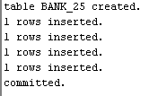
select * from BANK_25;
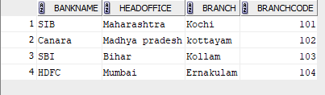
2.SAVEPOINT
INSERT INTO BANK_25 VALUES ('KERALA GRAMIN BANK','Mumbai','Alappuzha',105);
savepoint A;
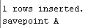
select * from BANK_25;

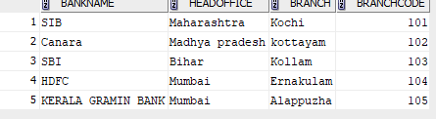
INSERT INTO BANK_25 VALUES ('Axis','Tamil nadu','Kozhikode',120);
savepoint B;

select * from BANK_25;
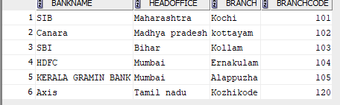
rollback to A;

select * from BANK_25;
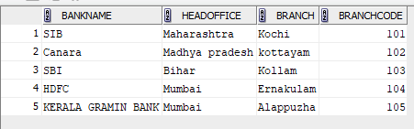

GRANT

GRANT SELECT ON BANK_25 TO c24csa28;
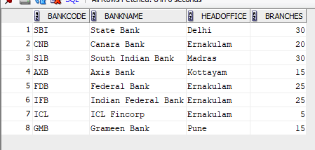

GRANT SELECT ON BANK_25 TO c24csa28;
select * from c24csa28.bank;
REVOKE
Revoke select on bank from c24csea28;
